**9. REACTJS-HQL**

**FOLDER STRUCTURE**

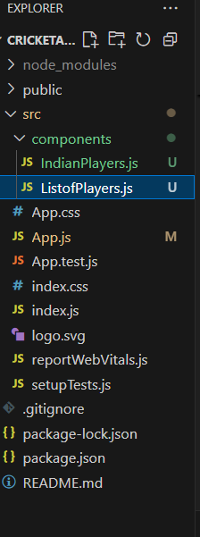

**ListofPlayers.js**

import React from 'react';

const ListofPlayers = () => {

    const players = [

    { name: 'Virat', score: 80 },

    { name: 'Rohit', score: 65 },

  { name: 'Rahul', score: 75 },

    { name: 'Dhoni', score: 90 },

    { name: 'Pant', score: 60 },

    { name: 'Bumrah', score: 85 },

    { name: 'Shami', score: 68 },

    { name: 'Jadeja', score: 92 },

    { name: 'Ashwin', score: 40 },

    { name: 'Hardik', score: 76 },

    { name: 'Surya', score: 88 },

  ];

const all = players.map((p, i) => (

    <li key={i}>{p.name} - {p.score}</li>

  ));

  const below70 = players.filter(p => p.score < 70).map((p, i) => (

    <li key={i}>{p.name} - {p.score}</li>

  ));

  return (

    <div>

      <h3>All Players</h3>

      <ul>{all}</ul>

      <h4>Players with Score Below 70</h4>

      <ul>{below70}</ul>

    </div>

  );

};

export default ListofPlayers;

**IndianPlayers.js**

import React from 'react';

const IndianPlayers = () => {

  const oddPlayers = ['Virat', 'Rahul', 'Pant', 'Shami', 'Ashwin'];

  const evenPlayers = ['Rohit', 'Dhoni', 'Bumrah', 'Jadeja', 'Hardik', 'Surya'];

  const [op1, op2, ...restOdd] = oddPlayers;

  const [ep1, ep2, ...restEven] = evenPlayers;

const T20 = ['Kohli', 'Rohit', 'Hardik'];

  const Ranji = ['Pujara', 'Rahane', 'Shaw'];

  const allPlayers = [...T20, ...Ranji];

return (

    <div>

      <h3>Odd Team Players</h3>

      <ul>

        <li>{op1}</li>

        <li>{op2}</li>

        {restOdd.map((name, i) => <li key={i}>{name}</li>)}

      </ul>

    <h3>Even Team Players</h3>

      <ul>

        <li>{ep1}</li>

        <li>{ep2}</li>

        {restEven.map((name, i) => <li key={i}>{name}</li>)}

      </ul>

      <h3>Merged T20 + Ranji Players</h3>

      <ul>

        {allPlayers.map((p, i) => <li key={i}>{p}</li>)}

      </ul>

  </div>

  );

};

export default IndianPlayers;

**App.js**

import React from 'react';

import ListofPlayers from './components/ListofPlayers';

import IndianPlayers from './components/IndianPlayers';

function App() {

  const flag = true; // change to false to test IndianPlayers

  return (

    <div>

      <h1>🏏 Cricket App</h1>

      {flag ? <ListofPlayers /> : <IndianPlayers />}

    </div>

  );

}

export default App;

**OUTPUT- (when flag=true)**

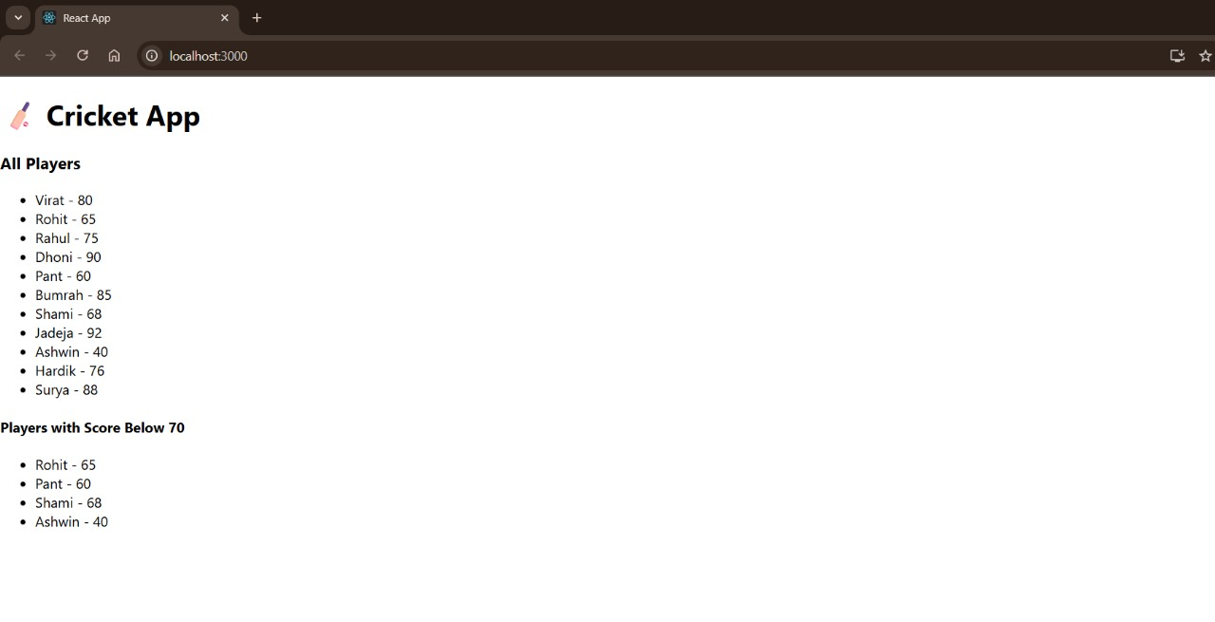

**OUTPUT-(when flag=false)**

